Ideation Phase
Brainstorm & Idea Prioritization
Date
Team ID | LTVIP2026TMIDS74706
Project name | Empowering India: Analysing the Evolution of Union Budget Allocations for Sustainable Growth
Maximum marks | 4 MARKS

Brainstorm & Idea Prioritization:
During the brainstorming phase of the Cosmetic Insights project, I explored various ideas to help users make better decisions when choosing skincare products. I focused on key areas like skin type suitability, brand-wise price comparison, and product ranking. I also considered using visual tools like word clouds to display common ingredients and bar charts to show product distribution by category. The goal was to build an interactive and insightful dashboard using Tableau. These ideas were chosen to solve real user problems and provide meaningful cosmetic recommendations through data
Step-1: Team Gathering, Collaboration and Select the Problem Statement
In the first step, our team was formed by gathering individuals with diverse skills and shared interest in data analytics. We collaborated to understand each member's strengths, such as data visualization, research, and communication. After a group discussion and brainstorming session, we shortlisted several potential issues in the cosmetics industry
problem statement: “Empowering India: Analysing the Evolution of Union Budget Allocations for Sustainable Growth”. This topic was chosen based on current market demand and its relevance to real-world cosmetic usage patterns.
Team Leader : Shanmukha Sri Venkata Bhaskar Udimudi
Team member : Chittabathula Yashwanth Ram
Team member : Adapa Gowtham Sri
Team member : Sai Durga Adapa

Step-2: Brainstorm, Idea Listing and Grouping
In this step, we listed multiple ideas related to analyzing Union Budget data, such as department-wise allocation trends, scheme-wise comparisons, year-over-year growth analysis, category distribution, and identification of top-funded sectors. These ideas were then grouped into broader analytical themes like financial trends, sector prioritization, funding growth patterns, and sustainable development focus areas. This helped us focus on the most impactful insights for building the dashboard.
Then, we grouped similar ideas to identify key features for the dashboard such as year-wise comparison filters, ministry/department analysis, scheme ranking, budget growth visualization, and top allocation highlights.

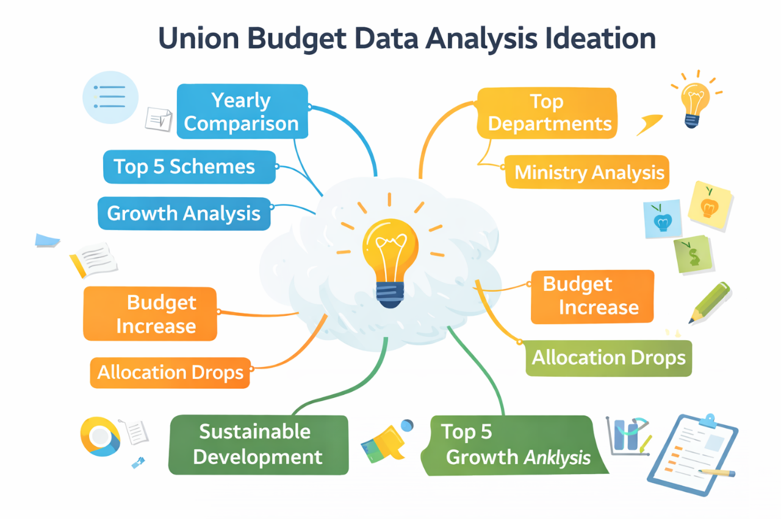

Step-3: Idea Prioritization
We prioritized ideas based on policy relevance, data availability, analytical value, and project objectives. Features like department-wise budget comparison, scheme-wise allocation trends, category-wise distribution, and identification of top 5 funded schemes were selected as the most impactful components for the dashboard.
Department-wise Allocation Analysis
• Compare budget allocations across ministries and departments for FY 2022–2023 and FY 2023–2024.
• Identify which departments received increased or reduced funding.
• Highlight major investment sectors such as infrastructure, agriculture, defense, and transportation.
Scheme-wise Budget Trends
• Analyze top government schemes and compare year-over-year budget estimates.
• Identify high-priority schemes receiving maximum allocation.
• Observe funding shifts across welfare, subsidy, and development programs.
Year-over-Year Growth Analysis
• Calculate increase or decrease in budget allocation between 2022–2023 and 2023–2024.
• Identify sectors showing consistent growth trends.
• Highlight areas where funding was reduced or reallocated.
Category-wise Distribution
• Analyze budget distribution across categories like Capital Expenditure, Revenue Expenditure, and Subsidies.
• Understand the balance between development spending and operational expenditure.
• Identify long-term investment patterns supporting sustainable growth.
Top Allocation Insights
• Identify Top 5 Ministries/Departments based on total allocation.
• Identify Top 5 Schemes with highest funding.
• Rank departments based on budget growth percentage.
Policy & Sustainable Development Focus
• Examine funding allocation towards infrastructure, agriculture, social welfare, and transportation.
• Understand government priorities aligned with sustainable development goals.
• Analyze how budget evolution reflects economic planning strategies.

